**LABSHEET 3: ASSEMBLY LANGUAGE PROGRAMMING OF**

**8085 MICROPROCESSORS**

**__________________________________________________________________________**

**Name: Vinayak V Thayil Roll Number:AM.EN.U4CSE21161**

**___________________________________________________________________________**

1. Write the assembly program for the given object code where the starting address of the program is 4200H and the functionality of the ALP program.

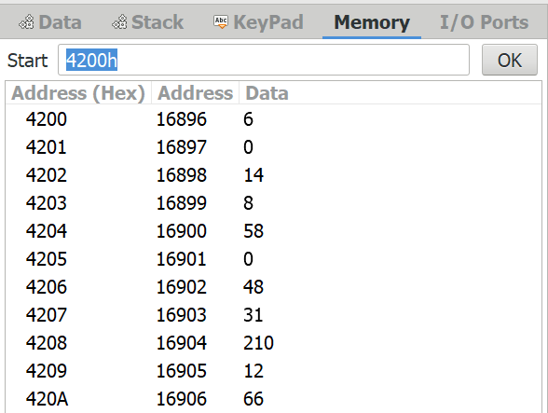

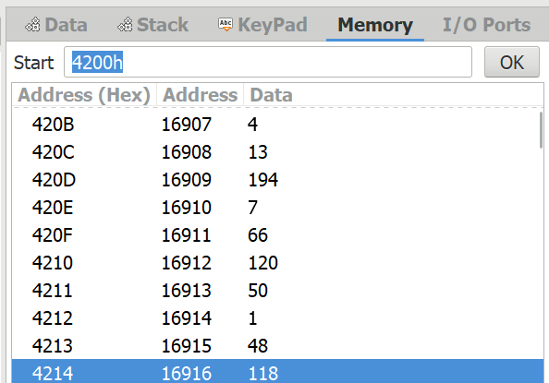

a)

|  |  |  |  |  |
| --- | --- | --- | --- | --- |
| Assembly | Instruction  Size | Memory  Address | Object Code in Hex | Flags or Register Flags change details |
| MVI B,00  MVI C,08  LDA 3000H  RAR  JNC 420CH  INR B  DCR C  JNZ 4207H  MOV A,B  STA 3001H  HLT | 2bytes  2bytes  3bytes  1bytes  3bytes  1bytes  1bytes  3bytes  1bytes  3bytes  1bytes | 4200  4202  4204  4207  4208  420B  420C  420D  4210  4211  4214 | 06 00  0E  3A  1F  D2  04  0D  C2  78  32  76 | PC 4202  C 08,PC 4204  A FF,PC 4204  A 7F,C 1,PC 4208  PC 420B  B 01,PC 420C  C 07,PC 420D  PC 4207  Z1 P1,C 1,A 08  ,PC4211  PC 4214  PC 4215 |

Note: Input data and the result of the program is in the following locations

. 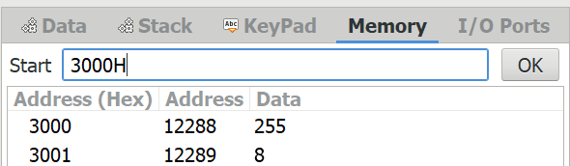

Show the usages of address bus, data bus, control bus and also the status of PC and relevant registers in the execution of each of the instruction.

**MVI B,00H:**

Address Bus: 4200 4201  
 Data Bus: 06H 00  
 Control Bus: Opcode Fetch Memory Read MemR= 0 Me  
 PC : 4200+1 4201+1  
 Registers: B =00H, C = 08H, A= X (content in the mem location)

**MVI C, 08H:**

Address Bus : 4202 4203  
 Data Bus : 0E 08  
 Control Bus: Write to Register C  
 PC: 4202+1 4203+1  
 Register B = 00H, C= 08H, A= X( content in the mem location)

**LDA 3000H:**

Address Bus: 4204 4205 4206  
Data Bus: 3A 00 30  
Control Bus: Memory Read   
PC: 4204+1 4205+1 4206+1  
Registers: B= X, C= 08H, A = X (content in the mem location)

**RAR:**

Address Bus: 4207  
Data Bus: 1F  
Control Bus : Rotate Accumulator Right  
PC : 4207+1 = 4208  
Registers : B = X, C= 08H, A =(CY)X (CY is the least significant bit of original A)

**JNC 420CH:**

Address Bus: 4208 4209 420A   
 Data Bus : D2 OC 42 (Not involved)  
 Control Bus: Jump if no carry  
 PC : 4208H 4209H+1 4210+1   
 Register: B = X, C = 08H, A = (CY)X

**INR B:**

Address Bus: 420B 420B  
Data Bus: (no mess access) 04  
Control Bus: increment by 1  
PC: 420C 420B+1  
Registers: B = X+1, C = 07H, A = (CY)X

**JNZ 4207H:**

Address Bus: 420D 420E 420F  
Data Bus: C2 07 42 (Not involved)  
Control Bus: 4200H 420E+1 420F+1  
PC: 4210 if jump not taken, updated to 4207h if jump taken  
Registers: B = X+1, C = 07H, A = (CY)X

**MOV A, B:**

Adress Bus: 4210  
 Data Bus: 78  
 Control Bus: Move B to A  
 PC: 4211 4210+1  
 Registers: B = X+1, C= 07H, A = X+1

**STA 3001H:**

Address Bus: 3001H 4211 4212 4213  
Data Bus: have value 32 01 30  
Control Bus: Memory Write  
PC : 4211+1 4212+1 4213+1  
Registers: B = X+1, C= 07H, A = X+1

**HLT:**

Address Bus: 4214  
 Data Bus: 76 (unchanged)  
 Control Bus: stop  
 PC: 4214  
 Registers: B = X+1, C = 07H , A = X+1  
 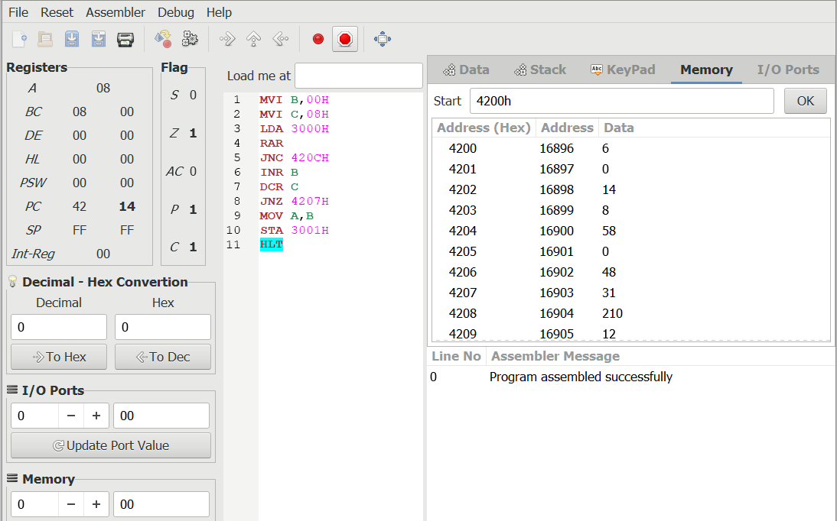

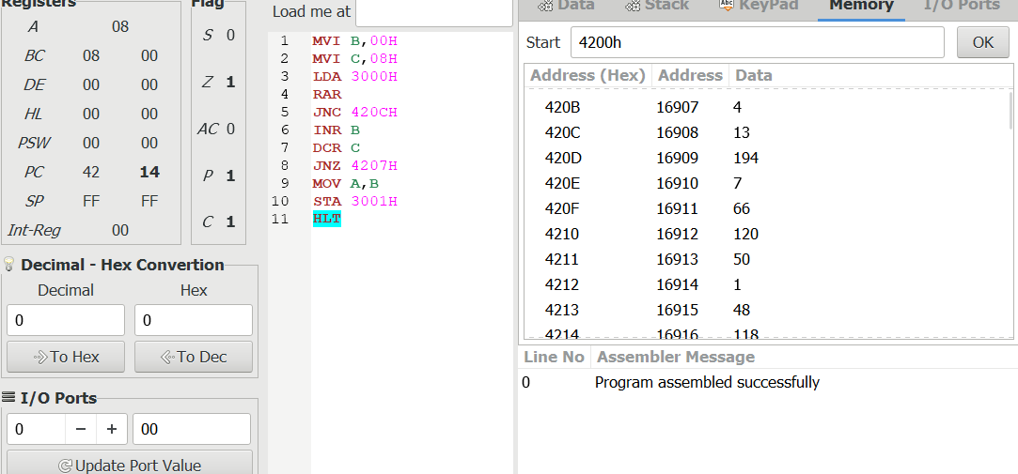

1. Fill the table for each of the assembly programs by selecting suitable instructions from 8085 Instruction Set. Show the output in 8085 simulators for the following programs and trace the program for 2 or 3 iterations. Explain each instruction and finally say what the program does.

|  |  |  |  |  |
| --- | --- | --- | --- | --- |
| Assembly | Instruction  Size | Memory  Address | Object Code in Hex | Flags or Register Flags change details |
| MVI A,12H  MOV B,A  MVI C,03H  MVI A,00H  Label1:ADD B  DCR C  JNZ Label1  STA 2001H  HLT | 2 bytes  1 byte  2 bytes  2 bytes  1 byte  1 byte  3 bytes  3 bytes  1 byte | 4200  4202  4203  4205  4207  4208  4209  420C  420F | 3E  47  0E  3E  80  0D  C2  32  76 | A 12,PC 4202  B 12,PC 4203  C 03,PC 4205  A 00,PC4207  A 12-A 24-A 36  P 1,PC 4208  C 02-C 01 -C 00  PC 4209  PC 4207  PC 420F  PC 4210 |

1. Mention the significance of Branch instruction JNZ. You can take the screenshot of register status in each iteration and copy it in the form of table.

MVI A, 12H

MOV B, A

MVI C, 03H

MVI A, 00H

Label1: ADD B

DCR C

JNZ Label1

STA 2001H

HLT

|  |  |
| --- | --- |
| Iteration1 | Iteration2 |
| Iteration3 | Final Result |

1. Write an assembly language program using loops to add the numbers starting from 1 to 50. B=1+2+3+………..+49+50

